With the blessing of the most reverend Metropolitan PHILIP
and the right reverend Bishop JOSEPH
of the Antiochian Orthodox Christian Archdiocese of North America,
the Very Rev Michel Najim and the Rev Patrick B. O’Grady
announce
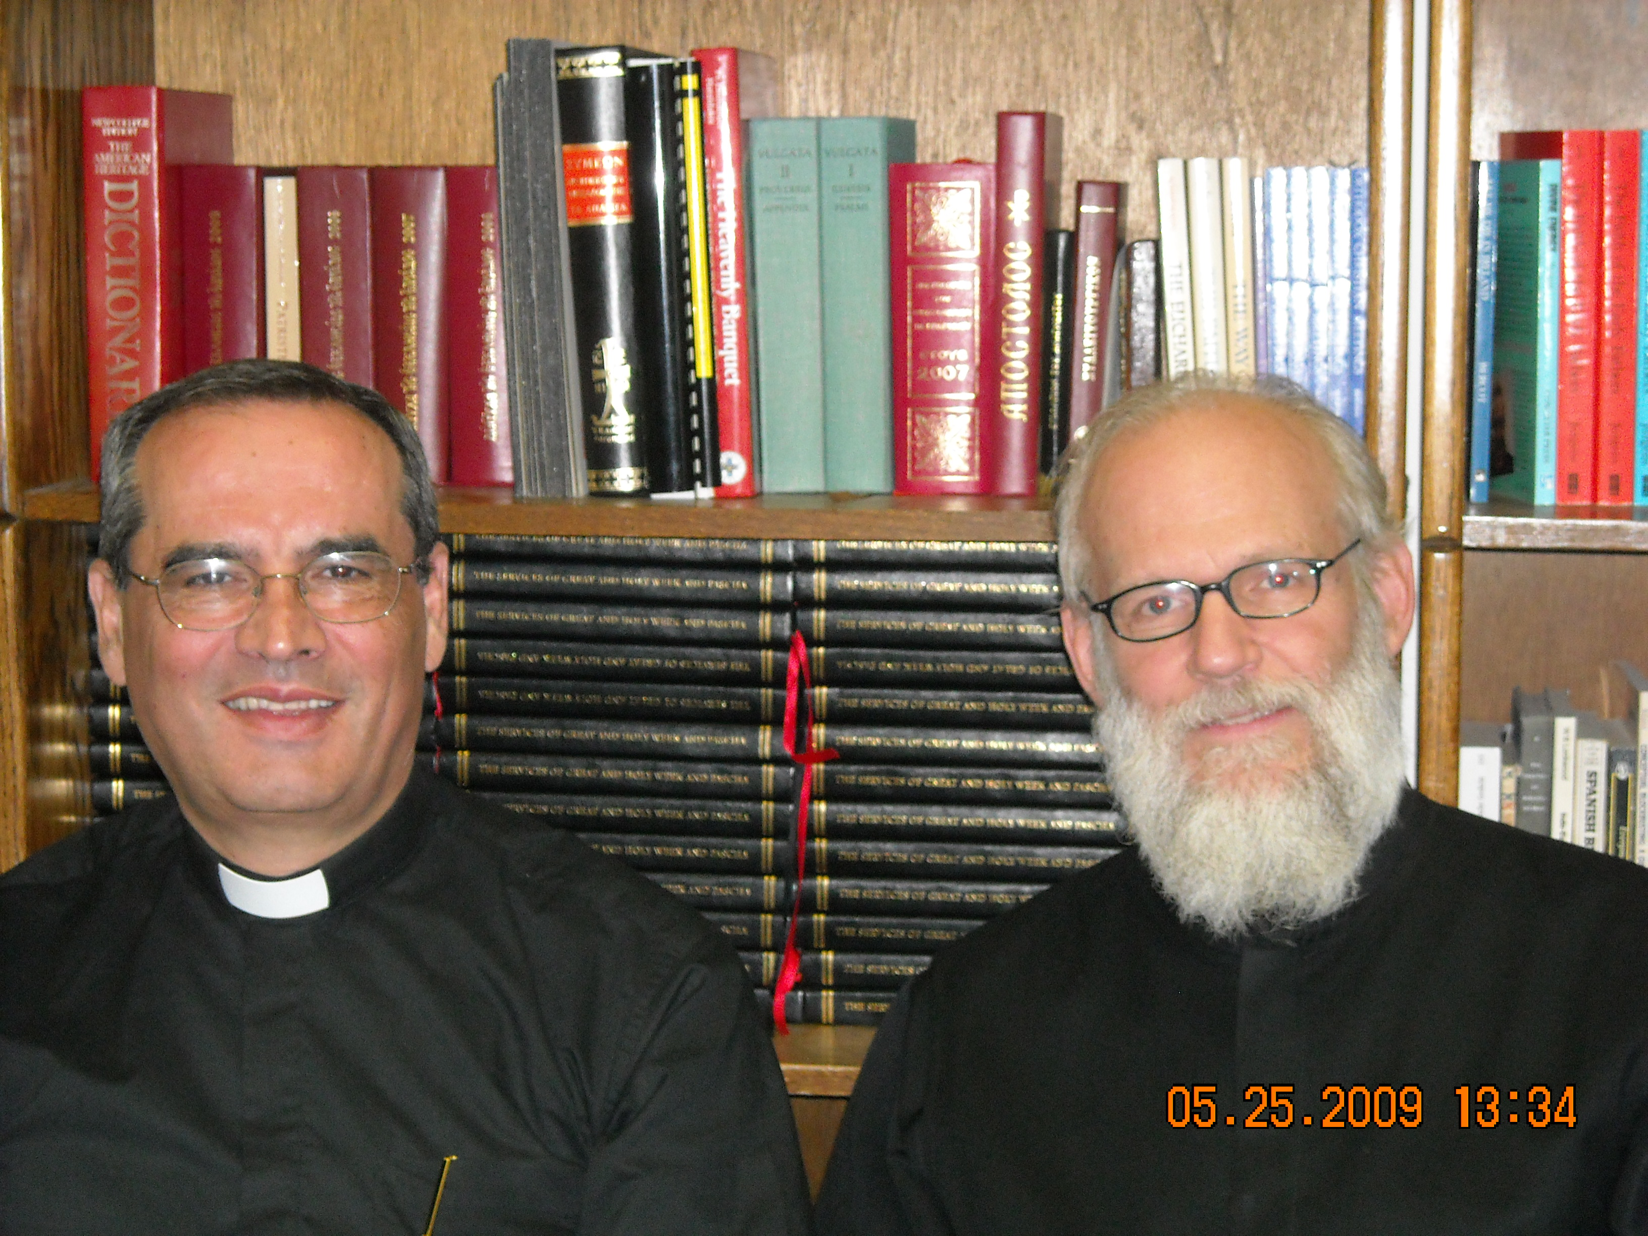

The Constitution of the Typikon
A detailed description of, and an unabridged system of rubrics for, the celebration of the regular and periodic services and of the mysteries of the Orthodox-Catholic Church.

Project Description

We are preparing a three-volume work which provides the description of all of the elements and the rubrics, developed with a view toward liturgical and historical clarity, of the regular services (taktai akolouthiai) of the Holy Orthodox-Catholic and Apostolic Church, following the ancient and enduring tradition of worship as expressed in the Antiochene-Constantinopolitan usage. In addition, this work will include regulations for celebrating the periodic (ektaktoi akolouthiai) of the Church, as well as of the holy Mysteries (sacraments).
The typikon of the Orthodox services is not a uniform recipe or monolithic deposit of tradition. There are a very great number of typika which have come down to us from many times and places. Our work gives account of each of these. However, there is a discernable presence of authoritative elements within the various typika which can be traced out and elucidated. This is a process which demands historical and theological research in order to arrive at consistent principles of usage. These liturgical and theological elements are taken into account in this Typikon.
As is well known, the calendar issue continues to present an obstacle to a uniform typikon. This work will allow for all possible cases of the eventual settlement of the calendar problem. As things stand now, those jurisdictions using the old calendar and those using the new can find applicable cases for any possible day.
Our work takes into account the extant manuscript and printed typika in which the Holy Church expresses the Faith in the ordering and regulation of any given service on any given day. The extant typika reflect the ecclesiastical regulation for worship in a given place. Therefore, the Constitution of the Typikon intends to regulate worship with special care for English-speaking Orthodox parishes and monasteries. The services of the saints will provide variations in certain cases to allow for a specific level of solemnity as blessed by local synods or hierarchs. The regulations will address parish needs foremost; however, detailed regulations for specific monastic usage are included using a system of brackets and footnotes where needed.
The three volumes are conceived as follows:
1st Volume, THEORY OF THE SERVICES AND MYSTERIES
A. the theory of the services: a description of the shape of all of the regular services of the daily cycle and the general principles of regulating their elements, along with specific outlines of each type of service [e.g., Saturday evening Great Vespers, lenten weekday matins, Paschal services, etc.];
B. the theory of the holy Mysteries and of the periodic services, with a description of the regulation of their celebration [e.g., Holy Baptism, Holy Anointing, etc., and the Paraklesis, Akathist, Memorials, etc.] and
C. outlines for all of the regular and periodic services, and of the mysteries, for handy reference.

2nd Volume, THE SERVICES OF THE FESTAL CYCLE
The specific regulations for the ordering of the regular services for every day of the fixed calendar, September through August, organized by month and date. On each day, the regulation for that day’s service is given in all of its possible cases (weekday, Saturday, Sunday, etc.), along with detailed footnotes specifying the rationale of any regulation where there are variations among the extant historical typika. In cases where a given day can fall within the moveable cycle, cross-reference is made to the 3rd volume (moveable cycle). These regulations are detailed and heavily annotated to justify every point, as well as to provide alternatives for festal celebration from place to place where needed, and to offer the full monastic regulation.

3rd Volume: THE SERVICES OF THE MOVEABLE CYCLE AND APPENDIX
The specific regulations for the ordering of the regular services for every day of the moveable calendar, encompassed by the Triodion and the Pentekostarion (Sunday of Publican & Pharisee through 1st Sunday after Pentecost [All Saints]). As in the 2nd volume, on each day, detailed footnotes specifying the rationale of any regulation are included. Here, as well, both parochial and the full monastic regulation are described.
This third volume will also carry an appendix with regulation for periodic services, and for concelebrations and services with the hierarch present, and with him serving, for church dedication (enkainia), and a glossary of liturgical terms used in the book. The appendix will also carry rubrics for the celebration of the holy Mysteries (sacraments).

Conclusion
We anticipate the release of this work in stages to test its complete utility and to ensure freedom from as many errors as possible. Therefore, the 1st volume as being the most important will be released first. Then, the following two volumes will be released together as the cross-referencing for any given service is extensive and requires the whole three-volume work to be effective in usage. In fact, the three-volume format provides for a minimum of flipping from place to place in practice. The work is conceived to be made available in the highest quality binding and durable paper, with ribbons in each of the three volumes.
Every parish church and monastic katholikon will want to employ this Constitution which fills the long-felt need for an English-language universal Typikon of the Orthodox Church.

